0.4: New note diagram

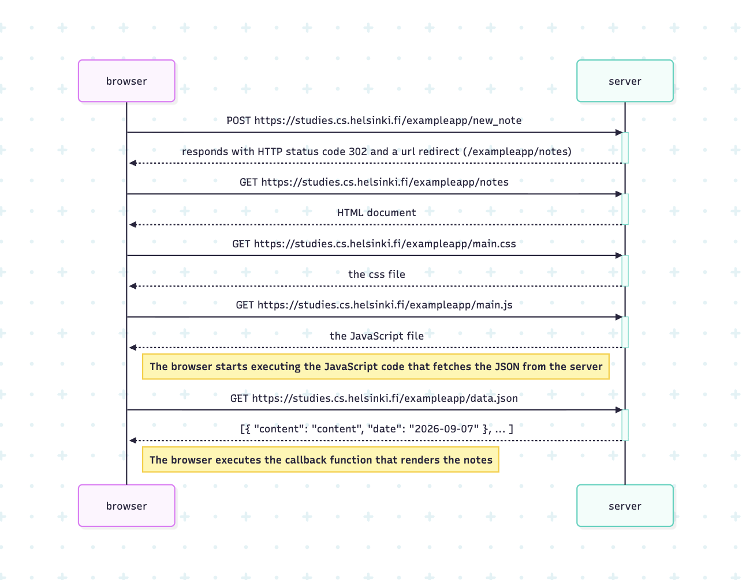

sequenceDiagram
participant browser
participant server

browser->>server: POST https://studies.cs.helsinki.fi/exampleapp/new_note
activate server
server-->>browser: responds with HTTP status code 302 and a url redirect (/exampleapp/notes)
deactivate server

browser->>server: GET https://studies.cs.helsinki.fi/exampleapp/notes
activate server
server-->>browser: HTML document
deactivate server

browser->>server: GET https://studies.cs.helsinki.fi/exampleapp/main.css
activate server
server-->>browser: the css file
deactivate server

browser->>server: GET https://studies.cs.helsinki.fi/exampleapp/main.js
activate server
server-->>browser: the JavaScript file
deactivate server

Note right of browser: The browser starts executing the JavaScript code that fetches the JSON from the server

browser->>server: GET https://studies.cs.helsinki.fi/exampleapp/data.json
activate server
server-->>browser: [{ "content": "content", "date": "2026-09-07" }, ... ]
deactivate server

Note right of browser: The browser executes the callback function that renders the notes

